AND GATE
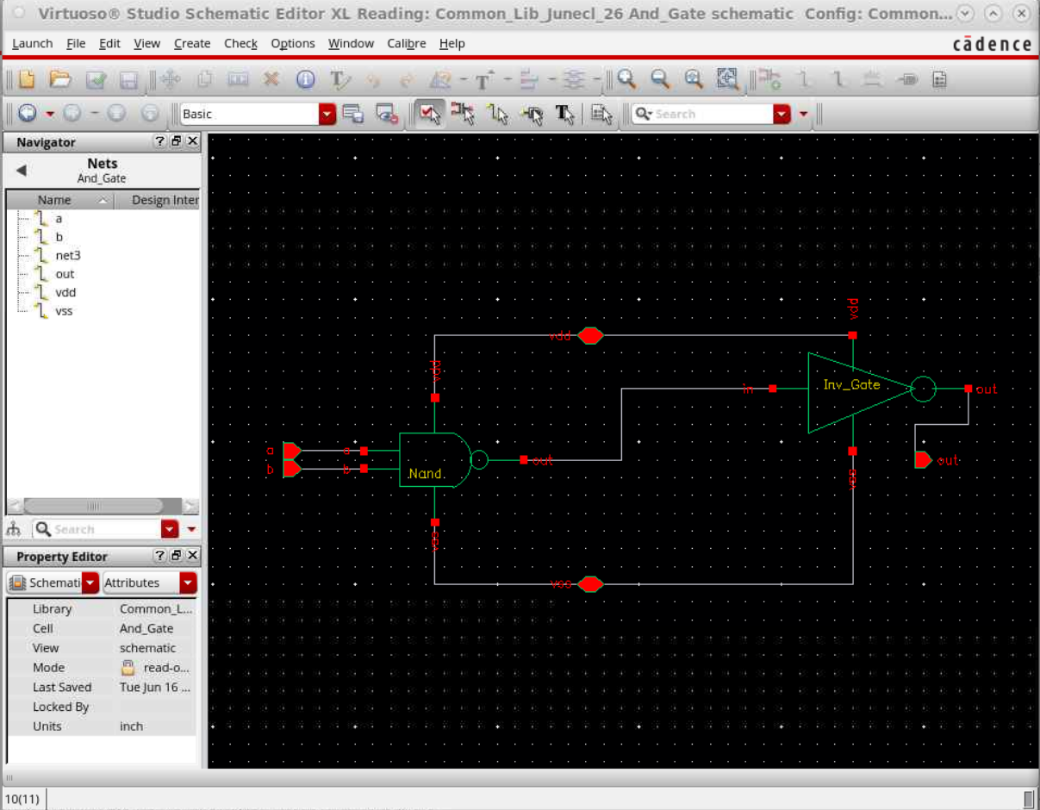
This was the schematic given for the AND gate and I had to design the layout based on the TSMC 28nm technology.
The layout:
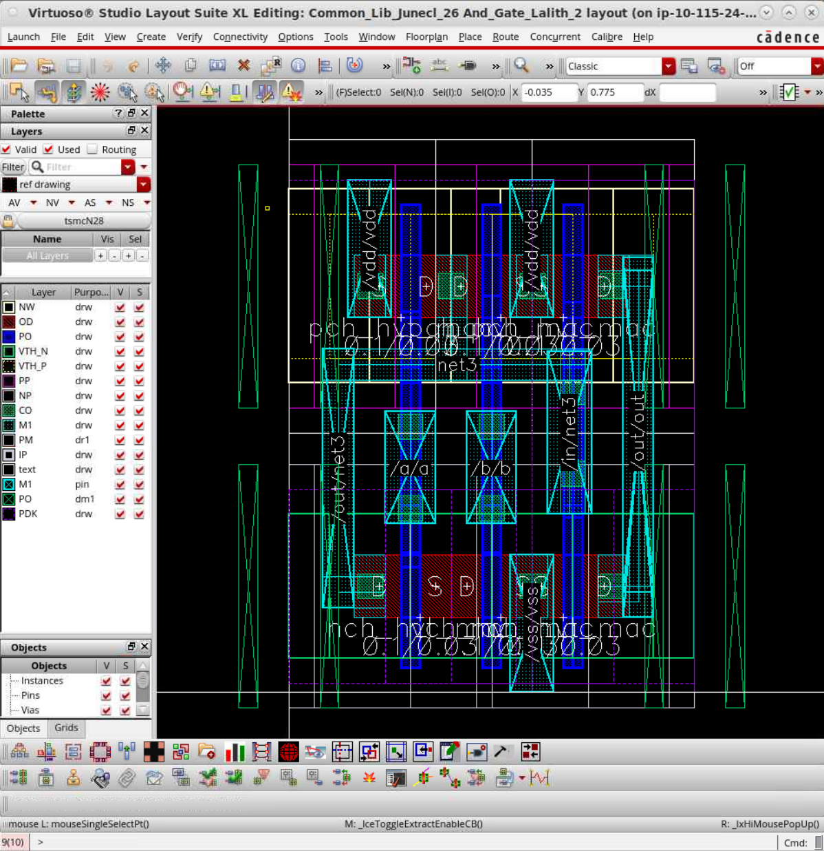
This was the combination of the NAND and INVERTER GATE I had to combine and connect and then bond all of this to the layout given. Upon adding the bulks , it gave LVS and ERC clean. I faced difficulty mainly in trying to wire this within minimal distance to each other, the metal-metal spacing had to be minimum to avoid the errors and excess use of material and to ensure minimum area. Below are the measurments.
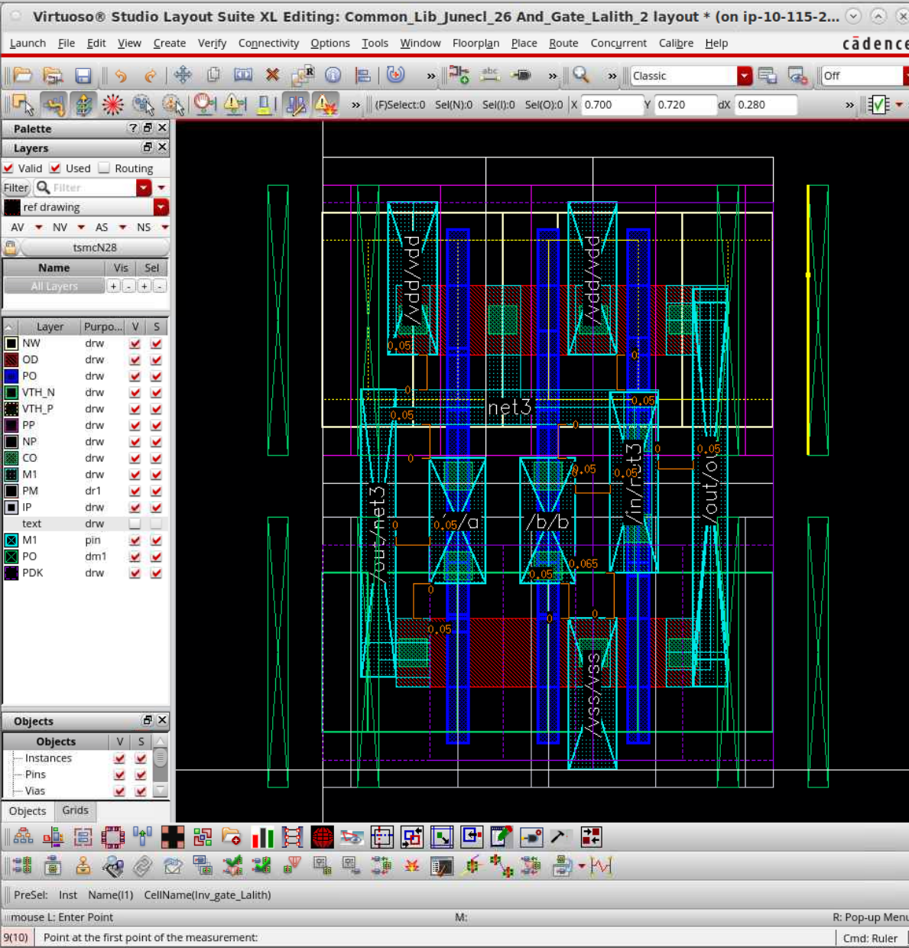
Some of the rules:
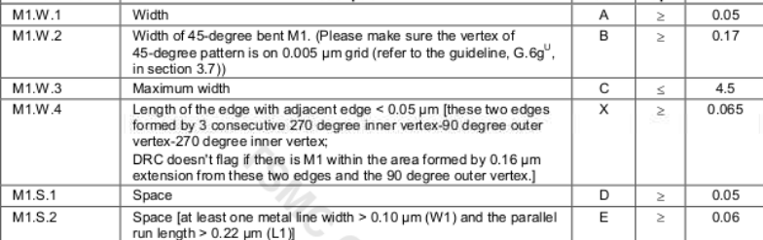
Here as I was saying I had to adhere to the M1.S.1 strictly to minimise, and I faced most problem with that rule.
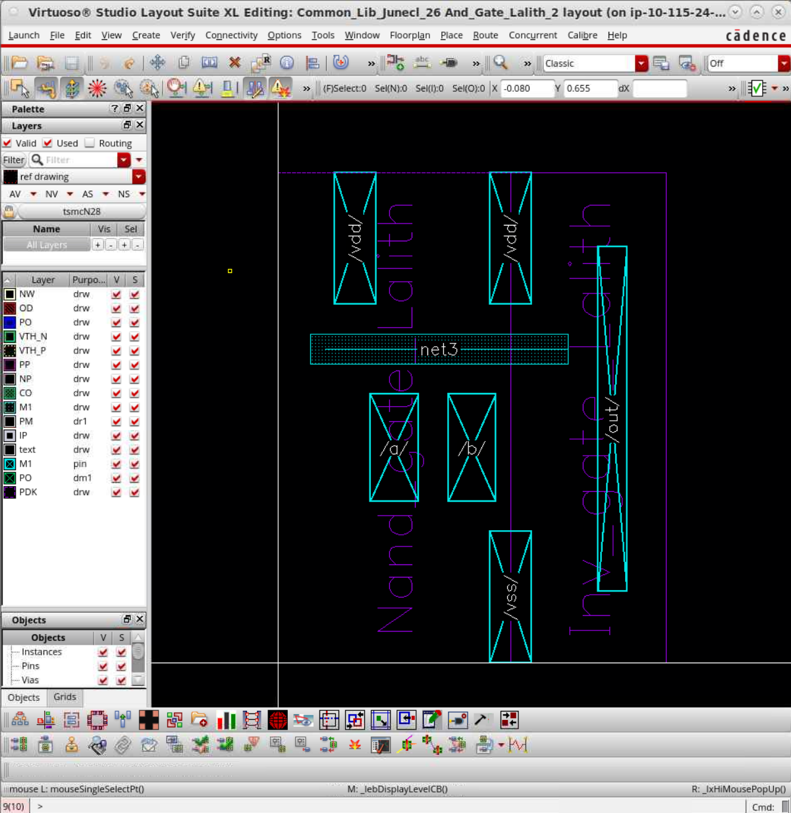
The above are the connection I placed on the NAND and INV gate in the AND level. The DRC:
